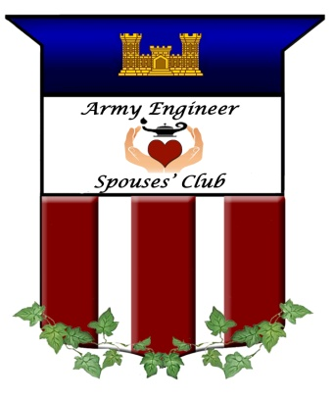

ARMY ENGINEER SPOUSES’ CLUB
Monthly Board Meeting Minutes
2 February 2022

Zoom Meeting Attendees: Sharise Spellmon, Tanya Toussaint, Mary Alice Jakso, Urvi Avichal, Brenda Schultze, Boumy Funes, Kerri Chase, Kara Anderson, Launa Klimowicz-Brown, Michelle Funkhouser, Erin Caswell, Jackie Caldwell, Bette Meuleners, Vanessa Joly, Stacy Lloyd, and Deb Wehr

CALL TO ORDER: 1934

UPCOMING DATES:
- 2/5 Candle-making at Paddywax Candle Bar
- 2/9 CB Sale Humphreys for EGM
- 2/16 Mexican Cultural Institute
- 2/22 Castle Readers Book Club, Verre Wine Bar
- 3/2 March Board Meeting, 10:00 am
- 3/4 Smithsonian Arts and Industries Tour
- 3/10 Cooking with Urvi

PRESIDENT: Mary Alice Jakso
- Mary Alice attended the December Board meeting/Cookie Exchange.
- She spoke with and emailed board members and members.
- She took and sent pictures from events to Erin, Terri, Vanessa and Michelle.
- She will keep promoting the new items on the Facebook page.
- She bought lanterns for Castle Boutique and gift boxes for Christmas cookies for next year.
- She went to the 249th storage locker and took out 18 blankets and gave them to Castle Boutique.
- She dropped off lanterns and other items to Castle Boutique.
- She set up tour and sent out evites for the Mexican Cultural Institute and Smithsonian.
- She is working on setting up a scavenger hunt at the Spy Museum.
- Mary Alice will keep promoting the decanter and items on FB. “Let’s hit $15,000 to give away to AEMA this year.”
- She is working on securing date for the AEMA Luncheon (beginning of May). She found a good location, the Harbor Grill in Occoquan. BSC has had luncheons there. Good space, good food and the service is great. We would like to offer the Zoom component again this year.
- The Fairfax residents loved the Christmas Cookie boxes!
- Need to start working on filling board positions for next year. Stacy, Brenda, Urvi are all PCSing this summer.
- The deadline for the AEMA applications is the end of February.
- Mary Alice spoke to the USO regarding meeting space.

Upcoming Events:
February 5 - we will learn how to make candles at Paddywax Candle Bar.
February 16 - we will tour the Mexican Cultural Institute. The Mexican Cultural Institute belongs to the Mexican Embassy in the United States. While the Embassy deals with the politics, economics, of Mexico, The Mexican Cultural Institute’s mission is to promote the Mexican Culture and Arts in the US. They are housed in the MacVeagh Mansion, which was designated as an Historic Site in the DC inventory of Historic Sites in 2012 and listed in the National Register of Historic Places in 2013.
February 22- Castle Readers Book Club will be meeting in the evening at Verre Wine Bar in Arlington, VA. The book we are reading is The Midnight Library by Matt Haig.
March 4 - we will head to the Smithsonian Arts and Industries for a docent led tour of their FUTURES! Exhibit. The North Hall is Futures of the Past: it is filled with artifacts borrowed from other museums to illustrate how previous generations thought about their futures, the West Hall is Futures that Work: it is filled with practical possible solutions for the future, the South Hall is Futures that Unite and the East Hall is Futures that Inspire.
March 10- Urvi is going to show us how to cook some yummy Indian food, so come hungry!

VICE PRESIDENT: Urvi Avichal
- Urvi noted that there were no events scheduled for January. Book Club had to be postponed.
- February 5th there is an outing scheduled at Paddywax Candles in Reston.
- February 22nd at 6:30 pm book club will be held at Verre Wine Bar in Arlington, VA.
- Urvi is planning the next event for March, a cooking class.
- Urvi is trying to plan a West Point Trip for some time in April. They are not currently doing Alumni Tours because of Covid, but they do have a tourist tour that takes you on the campus with various stops. She contacted someone at the Alumni Association to see if we can schedule a meal in the Mess Hall. She is waiting to hear back.
- Urvi is coordinating the Egg Decorating with Launa for the spring.

SECRETARY: Brenda Schultze
- A motion to approve the December 2021 board meeting minutes was made by Urvi Avichal and seconded by Michelle Funkhouser. The motion passed unanimously and the December AESC Board Meeting Minutes were approved.
- She attended the December Board meeting/Cookie Exchange.
- She prepared the December Board Meeting minutes and sent to the board for review.
- She prepared and sent the February agenda and Board Report Template to the board.
- She sent correspondence.
- She assisted board members.
- Brenda updated the Calendar and sent to board.
- She updated the Motions list on the Drive.
- She will complete the February minutes and send to the board.
- She will prepare for the March board meeting.

TREASURER: Boumy Funes
- Reconciliation:
Account Balances (as of 31 January 2022)
  - BB&T Statement, $29,130.15
  - Register and General Ledger, $29,665.75
  - PayPal amount transferred to BBT since last report: $306.47
  - Square deposits to BBT: $2,245.14
  - Cash/Check Deposit, $1,177.00
  - W&M Report (Castle Boutique) as of 02/01/22
    - Income YTD: $12,914.55
    - Budget: $14,000
    - Expenses (purchases, PP fees, shipping): (-$5,796.61)
    - Remaining Available Funds: $8,203.39
- Boumy noted that BBT is transitioning to Truist so we will be seeing that name on documents.

AEMA CHAIRPERSON: Kerri Chase
- Kerri stated that the final Thank You letters were sent to the cocktail Donors.
- PenFed account access has been fully updated.
- All monthly financial reports have been completed from September 2021 to current.
- The PenFed accounts have been reviewed.
- She has been promoting AESC and awards in various social events and personal social media accounts.
- Kerri is still working on PayPal access. Boumy will help Kerri.
- Kerri will assist AESC in upcoming awards process.

SCHOLARSHIP: Kara Anderson
- Kara checked the mailbox and forwarded items to the appropriate board member.
- Three applications have been received to date.
- She wrote articles for the Castle Gram and submitted to Michelle.
- Kara is verifying applicants AESC parent/guardian membership and obtaining official transcripts.
- ***No contact made with the 2017-18 and 2018-19 GKM awardees that have not sent an update (snail mail, emails and contacting mom who was a member when the kids applied) for payment. We still have the $2000 for these winners. It may have to be forfeited by the awardees at this point. Kara will discuss with Kerri.
- Kara will coordinate with Basia to send reminders to members for the AEMA applications.
- Kara received a check from Lynch Creek fundraiser.

CIRCULATION: Basia Kent
- Basia sent the following emails: AESC CG, Decanter promo and Meeting Zoom link.
- She is keeping email list updated.
- She will mail out the February Castle Gram.
- She will monitor the inbox and scrub the contact list based on new members, members that did not rejoin, and email address undeliverables.

WEBMASTER: Terri Stevens
- Terri took the Castle Boutique offline from December 16-January 10th.
- She added updated membership roster to the Membership page.
- She added the December and January Castle Gram and November Meeting Minutes after approval.
- Terri added the Cookie Exchange photos.
- She updated the link to the AEMA Articles of Charter.
- She added MG Pat Stevens to Remembering Engineers page.
- She added February and March events.

NEWSLETTER/CASTLEGRAM: Michelle Funkhouser
- Michelle created and published the January issue of the Castle Gram.
- She communicated with board members as needed.
- She will request/gather information for the March issue of the Castle Gram. She requested Irish recipes for March with a photo, could be a stock photo. Please include origin of photo, if possible.

Deadline for submissions is February 23, 2022 for the March issue of the Castle Gram.

NOMINATIONS: Bette Meuleners
- Bette noted that it is time to start thinking about nominations for the slate for next board year. She believes everyone on board could serve another year.
- Bette asks members to keep encouraging Engineer friends to join AESC and to be on the board. Pay special attention to new to the area engineer spouses you meet.
- She wrote message she plans to send to all the current board members to see if they want to remain on the board.
- She is working with Terri to make sure that all the emails going to nominations go to Bette.
- Be looking for an email from Bette about whether or not you plan to stay on the board or if you know anyone who would like to be on the board.

HOSPITALITY/ RESERVATIONS: Erin Caswell
Nothing to Report

WELFARE/SERVICES: Jennifer Broderick
- Lynch Creek Fundraiser ended up raising $1,156 this year. Thank you to all who ordered. Jennifer sent the W-9 to their fundraising department in order to receive the money. Kara noted a check was received in mail.
- Wreaths Across America is active if you would like to get a head start for this year. This is our group page: https://www.wreathsacrossamerica.org/pages/157166/
Jennifer confirmed us for another year of sponsorships to make sure we are official and good to go.
- Honor Flight-Flights are postponed through February 2022. She will continue to check back on when they start up again. If you would like to keep an eye on the schedule the link is: https://www.honorflight.org/current-trip-schedule.html

KNOLLWOOD BAKE SALE: Priscilla Noah
- Nothing noted

MEMBERSHIP: Jackie Caldwell and Jennifer Broderick
- Jennifer reports that she updated the membership roster. There are currently 165 members (as of 1/27/22). If you need a copy of the Membership Roster, please feel free to email Jennifer.
- Jennifer will continue to update the membership roster as membership applications come in.
- Jackie reports that 165 2021-2022 Red Books were mailed from the Dulles Distribution Center (USPS) on Dec. 20, 2021. To date, no mailed Red Books have been returned to our AESC mailbox.
- Jackie and team had corrected many addresses due to PCs moves.

THE FAIRFAX LIASON: Isabel Stevens
- Isabel delivered the boxes of cookies the day of the cookie Exchange. Several people told Isabel how wonderful the cookies were, both this year and last year. They were especially pleased to be remembered by the AESC.
- Mary Alice stated that Isabel stated that there was a possibility of having the AEMA luncheon at the Fairfax, but Covid protocols would need to be in place. Mary Alice is researching another location, Harbor Grille in Occoquan.

HISTORIAN: Erin Beer
Nothing to report

FACEBOOK/PUBLICITY: Vanessa Joly
- Send anything to be posted on Facebook and/or Instagram to my email address, jolyvl@yahoo.com.
- Posts and number reached:
  - Dec 1: Gnome Post, FB (533) and IG (46)
  - Dec 2: Stocking Stuffers, FB (204) and IG (33)
  - Dec 4: Lynch Creek Farms Deadline, FB (201) and IG (40)
  - Dec 11: Castle Boutique Holiday Schedule, FB (160) and IG (39)
  - Dec 15: Blankets and Tervis Tumblers, FB (319) and IG (41)
  - Dec 25: Merry Christmas, FB (140)
  - Dec 31: Happy New Year, FB (87)
  - Jan 9: Survey for Engineer Spouse, FB (368) and IG (53)
  - Jan 10: Castle Boutique Open and Engineer Flask, FB (357) and IG (40)
  - Jan 12: Wreaths Across America, FB (127) and IG (35)
  - Jan 17: Preorder Decanter video, FB (407)
  - Jan 19: Preorder Decanter video (2), FB (301)
  - Jan 26: Decanter Flyer, FB (465) and IG (46)
  - Jan 30: Castle Boutique Valentine’s Post, FB (159) and IG (23)

- We have reached 927 Facebook Followers (+22 since November) and 92 Instagram Followers (+3 since November).
- Vanessa will post at least once a week.
- She will post post about AEMA. Kerri will send her something to share.
- Vanessa received a request from a military spouse to share her survey on the psychological well-being of military spouses during the pandemic. Should she share all requests or get approval from Mary Alice and/or the board on a case by case basis. How many do we want to allow? Discussion followed regarding privacy and how much research and vetting Vanessa needs to do. It was decided to keep it just to Engineer spouses for posting surveys and bring it to board.

PARLIAMENTARIAN: Launa Klimowicz-Brown
- Launa will have the final touches to changes to Constitution and Bylaws finished this week and she will put it out to board members to see if they have any questions or concerns to let her know.
- Launa expects to have it ready by the end of the month after she hears back from the board. Then she will have the final version out to the membership because the entire membership will need to vote on it because of the changes that we are making. April will likely be the month we vote on it.
- Launa will research how the vote should work. Michelle researched Constitution and if we are amending the Constitution then it is 2/3 of votes cast of however many voted.
- Launa will get the draft to board members by 2/15 and ask for responses back by 2/27. Then in March she will send an email vote out to the General Membership and ask for a vote by March 31st. She will make a summary page with what the changes are for everyone to see.

CASTLE BOUTIQUE: Stacy Lloyd
- Castle Boutique sold over $2405 in online sales during December & January.
- Sold $1,479.50 at Humphreys in-person sale on December 7.
- Stacy scheduled an in-person sale for Wednesday, February 9 at Humphreys during EGM.
- She submitted cash from the two in-person sales to Boumy.
- She submitted invoices to Boumy for reimbursement.
- She created a special for January, members-only coupon in Weebly, & flyer for CastleGram.
- She created monthly member specials & ‘new’ Castle Boutique featured items through May.
- She picked up merchandise from Mary Alice.
- She completed updated inventory for Basia’s stored inventory & wrote reimbursement for sold items.
- She replenished shipping labels, paper, ink, & mailers that Sarah needed for fulfillment.
- She engraved flasks & added to CB inventory as new January featured item.
- She worked to get cast & sample for the Engineer Globe Decanter.
- She created flyers & video for decanter pre-orders.
- Took pre-orders for decanters
(41 of the 50 have been pre-sold) to date $2875 in decanter sales w/$1030 in profit. (By the time of the meeting all 50 have been pre-sold.)
- Updated inventory on website
- Picked up Artel to replenish inventory, will feature in February.
- She will continue working on new inventory items – Castle apron & grill set (Father’s Day) Castle engraved phone charging station, stained glass, ID holder lanyards.
- She will work on ordering regular inventory that we are low/out of – cookie cutters, bullet pens, stationary, Artel.
- Stacy noted that we need to begin looking/advertising for new Castle Boutique Chair to take over this spring/early summer when she will PCS.
- Stacy will continue to monitor shipping cost average to determine whether we need to increase or not.
The total shipping loss since Sarah and Stacy took over on October 19 is $55.43 but that was 3 months of old data during a high-volume time. One order of 8 blankets, as well as shipping the large gnomes somewhat skewed this data. (Decanters will have their own specified shipping cost, customers were notified via email when pre-ordering)

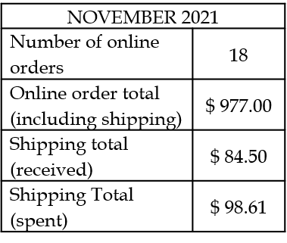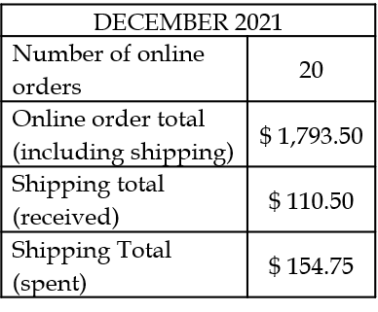

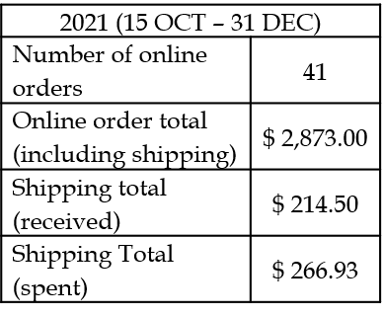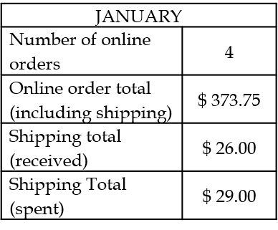

- Is there a specific administrative budget set up for Pay Pal & Square fees, do those fees come off of incoming profit, or are they counted again Castle Boutique budget?
- Since we are meeting electronically, do we have a current procedure/timeframe in place for submitting reimbursement requests? Stacy has a check for Boumy. They will meet.
- Stacy will prepare for the upcoming EGM sale. She will also have snacks for donations. She will continue working on finding new inventory. She is working on a charging stand.
NOTES:
- Sharise thanks everyone for all they do. She has missed seeing everyone. Thank you to Stacy for everything you have been doing. They are looking at Sunday, May 1st for AEMA Luncheon. Thank you to Kerri for all you are doing.

TIME OF ADJOURNMENT: 2043

